

P.O. Box BE 277. Ganges Road,
Belvedere, Harare. ZIMBABWE
Office: W102. First Floor. Admin-Block
Tel: 263-4-741422-37 Ext: 2331
SIST UNDERGRADUATE UNIT
SOFTWARE ENGINEERING

BTech in Software Engineering

E-learning for Supplementary Education

Project Documentation

THULANI MANDLAENKOSI MPOFU

H200905Y

Supervisor: Mr K. CHIWORERA

2023- 2024

CERTIFICATE
THIS IS TO CERTIFY THAT RESEARCH WORK EMBODIED IN THIS THESIS ENTITLED “E-LEARNING FOR SUPPLEMENTARY EDUCATION” THULANI MANDLAENKOSI MPOFU (REGISTRATION NO: H2OO9O5Y) STUDYING AT HARARE INSTITUTE OF TECHNOLOGY FOR PARTIAL FULFILMENT OF BACHELOR OF TECHNOLOGY DEGREE IN SOFTWARE ENGINEERING TO BE AWARDED BY THE HARARE INSTITUTE OF TECHNOLOGY.THIS RESEARCH WORK HAS BEEN CARRIED OUT UNDER MY GUIDANCE AND SUPERVISION AND IT IS UP TO MY SATISFACTION.

Student’s signature …………………… Date ...…. /…..…/……….
(Thulani Mandlaenkosi Mpofu)
Department of Software Engineering
Harare Institute of Technology

Supervisor’s signature …………………. Date ……. /……..……/……
(Mr. K. Chiworera)
Department of Software Engineering
Harare Institute of Technology
P O Box BE 277
Belvedere
Harare, Zimbabwe

PAPER PUBLICATION CERTIFICATE

THIS IS TO CERTIFY THAT RESEARCH WORK EMBODIED IN THIS THESIS ENTITLED “E-LEARNING FOR SUPPLEMENTARY EDUCATION” WAS CARRIED OUT BY STUDYING AT HARARE INSTITUTE OF TECHNOLOGY FOR PARTIAL FULFILMENT OF BACHELOR OF TECHNOLOGY DEGREE IN SOFTWARE ENGINEERING TO BE AWARDED TO THULANI MANDLAENKOSI MPOFU (REGISTRATION NO: H200905Y) HARARE INSTITUTE OF TECHNOLOGY HAS PUBLISHED ARTICLE ENTITLED “E-LEARNING FOR SUPPLEMENTARY EDUCATION” FOR PUBLICATION BY THE HARARE INSTITUTE OF TECHNOLOGY SCHOOL OF INFORMATION SCIENCES AND TECHNOLOGY JOURNAL.

Date: ……………………….

Place: ………………………

Mr. Chiworera
Supervisor & Lecturer from SE department, Harare Institute of Technology, Harare, Zimbabwe
Signature ……………………….
Stamp

Name & Signature of Dean

………………………………………………………………………………………

THESIS APPROVAL CERTIFICATE
This is to certify that research work embodied in this thesis entitled “E-LEARNING FOR SUPPLEMENTARY EDUCATION” was carried out by studying at Harare Institute of Technology for partial fulfilment of bachelor of technology degree in Software Engineering to be awarded by Thulani Mandlaenkosi Mpofu (registration no: H200905Y) Harare Institute of Technology has published article entitled “E-LEARNING FOR SUPPLEMENTARY EDUCATION” for publication by the Harare Institute of Technology school of information sciences and technology journal.

Date:

Place:

Examiners Signature and Name:

(………………………………………………………………)

(………………………………………………………………)

STATEMENT OF ORIGINALITY
We hereby certify that we are the sole authors of this thesis and that neither any part of this thesis nor the whole of the thesis has been submitted for a degree to any other university or institution.
We certify that, to the best of our knowledge, the current thesis does not infringe upon anyone’s copyright nor violate any proprietary rights and that any ideas, techniques, quotations or any other material from the work of other people included in our thesis, published or otherwise, are fully acknowledged in accordance with the standard referencing practices. Furthermore, to the extent that we have included copyrighted material that surpasses the boundary of fair dealing. We certify that we have obtained a written permission from the copyright owner(s)to include such material(s)in the current thesis and have included copies of such copyright clearances to our appendix
We declare that this is a true copy of thesis, including any final revisions, as approved by thesis review committee.
We have checked write up of the present thesis using anti-plagiarism database and it is in allowable limit. Even though later on in case of any complaint pertaining of plagiarism, we are sole responsible for the same and we understand that as per hit norms, the institute can even revoke Bachelor of Technology degree conferred to the student submitting this thesis.
Date:
Place:
…………………………………………………
Mr. T. M. Mpofu(H200491A) Harare Institute of Technology, Harare, Zimbabwe
…………………………………………………
Mr. K. Chiworera Harare Institute of Technology, Harare, Zimbabwe

Abstract
In Zimbabwe extra lessons are conducted physicals in most parts of the country. This paper presents the design and development of an innovative e-learning system tailored to support students who are underperforming in their academic subjects. The proposed web platform facilitates interactions between students and teachers through a range of features, including document verification by the admin, subscription management for teachers, and performance ratings by students. Verified teachers can subscribe to offer their services, upload educational materials, and schedule video conferences with students. Students can search for teachers, request video conferences, and rate their experiences to ensure quality. The platform aims to enhance personalized learning experiences, ensuring that students receive the necessary support to improve their academic performance. By integrating secure document verification, flexible subscription plans, and comprehensive performance feedback, this e-learning system addresses the critical need for personalized educational assistance in the digital age.

Preface
This report presents the design and implementation of e-learning for supplementary education. The system is designed to provide a secure and reliable way to conduct online lessons. The system uses verification of teachers’ documents to ensure trust and credibility in the community and video conference to provide live lessons.
The report is divided into several sections. The first section introduces the e-learning system and its benefits. The third section describes the system architecture and its components. The fourth section discusses the design features of the system. The fifth section provides details on the implementation of the system. Finally, the last section presents the results of the testing and evaluation of the system.

Acknowledgements
I would like to express my sincere gratitude to my supervisor MR Chiworera for her guidance and support throughout the development of this project. I would also like to thank the staff at the library for their assistance in providing me with the necessary resources. Finally, I would like to thank all the participants who took part in this study.

Dedication
This project is dedicated to my family, who have always been my inspiration and motivation. Their unwavering support and encouragement have been instrumental in my success. I would also like to dedicate this project to my friends and colleagues who have provided me with valuable insights and feedback throughout the development process. Without their help, this project would not have been possible.

Contents
CERTIFICATE 2
PAPER PUBLICATION CERTIFICATE 3
THESIS APPROVAL CERTIFICATE 4
Abstract 6
Preface 7
Acknowledgements 8
Dedication 9
1 Chapter 1 Introduction 13
1.1 Background 13
1.2 Problem Statement 13
1.3 Objectives 13
1.4 Hypothesis 14
1.5 Justification 14
1.6 Proposed Tools 14
1.7 Feasibility 15
1.7.1 Technical 15
1.7.2 Economic 16
1.7.3 Operational 17
1.8 Project Plan 17
1.8.1 Time Plan 17
1.8.2 Gant Chart 18
2 Chapter 2 Literature Review 19
2.1 Introduction 19
2.2 Alternative Works 19
2.3 Conclusion 21
3 Chapter 3 Analysis 23
3.1 Information gathering tools. 23
3.1.1 Questionnaire 23
3.1.2 Interviews 24
3.1.3 Observation 25
3.2 Description of existing system 27
3.3 Data Analysis 27
3.3.1 UML Context Diagram 27
3.3.2 Data Flow Diagram 28
3.4 Evaluation of Alternative System 29
3.4.1 Functional and Non-Functional Requirements 29
3.4.2 Use case Diagrams 31
4 Chapter 4 Design 32
4.1 System Diagram 32
4.1.1Context Diagram 32
4.1.2 Dataflow Diagram 33
4.1.3 Activity Diagram 34
4.2 Architectural Design 35
4.2.2 Networking 35
4.3 Database Design 36
4.3.1 Entity Relationship Diagram 36
4.3.2 Normalized Database 37
4.4 Program Design 39
4.4.1 Class Diagram 39
4.4.2 Sequence Diagram 40
4.4.3 Package Diagram 41
4.5 User Interface 42
4.5.1 Home Page 42
4.5.2 Registration 43
4.5.3 Login 44
4.5.4 student dashboard 44
4.5.5 Teacher’s dashboard 45
4.5.6 teacher starts video conference 45
4.5.7 Teacher viewing and marking students work 46
4.5.8 students viewing results 46
4.5.9 teachers making subscriptions 47
4.5.10 Videoconference 47
4.5.11 Admin verifying documents. 48
4.5.12 Students Rating the Teacher 48
5 Chapter Five Implementation and Testing 49
5.1 Pseudo Code 49
5.1.1 User registration and authentication 49
5.1.2 Teacher Verification 49
5.1.3 Content Management 50
5.1.4 Video conferencing 51
5.1.5 Rating System 51
5.1.6 Book Sessions 52
5.1.7 Real Code 53
5.2 Software Testing 55
5.2.1 Unit Testing 55
5.2.2 Integration Testing 56
5.2.3 System Testing 57
5.2.4 Database testing 57
5.2.5. Acceptance Testing 58
5.3 Installation and Deployment 59
5.4 Maintenance 59
6 Chapter 6 Conclusion and Recommendations 60
6.1 Results 60
6.1.1 Successful Registration 60
6.1.3 Successful teacher verification 61
6.1.4 Successful student work upload 61
6.1.5 Successful Teacher rating 62
6.1.6 Successful Video conference 62
6.1.7 validation 63
6.1.8 Teacher Successfully add services. 63
6.1.9 Document Verification 64
6.2 Summary 65
6.3 Recommendations 67
6.4 Future Works 68
BIBLOGRAPHY 69
APPENDIX 1: DATA COLLECTION TOOLS 69
APPENDIX 11 User Manual of the working system 70
APPENDIX 111 Sample Code 72
Refences 76

1 Chapter 1 Introduction

1.1 Background
In recent years, the Zimbabwe economy has not been doing well causing people to do or look for side hustles so that they can ends meet. As for teachers, there has been a growth for supplementary education or extra lessons so that they can earn a few extra cash in their pockets. Furthermore, many students are seeking additional support outside of traditional classrooms settings to enhance their learning and improve their academic performance. However, access to quality supplementary education is often limited, especially in rural areas where there is a shortage of qualified teachers. Currently there is lack of options for supplementary education in Zimbabwe. Students must travel or sometimes go to their teachers’ houses to conduct those extra lessons; this is due to teachers not having their own infrastructure to teach. Doing lessons in your teacher’s household might not be comfortable for students. And the other problem is accessibility issues, students might travel long distances due geographical barriers and limited transportation options, for them to go and seek help from the best teachers. Implementing a solution that connects students with the best teachers from all over the country, allowing them to access high-quality education from the comfort of their homes through an online e-learning platform that provides supplementary education.

1.2 Problem Statement
Students in Zimbabwe who are underperforming academically often lack the resources and support needed to improve their performance. The existing education system does not provide sufficient mechanisms for personalized tutoring and supplementary learning outside the classroom. This leads to a widening educational gap, with many students failing to reach their full potential.

1.3 Objectives
- To create a web application which will allow students to connect with teachers across the country.
- To verify teachers’ documents
- To allow teachers to make subscriptions.
- To allow teachers to set profile
- To allow students to rate teachers’ performance.
- To allow teachers to start video conferences.

1.4 Hypothesis
I believe that by developing an online e-learning platform for supplementary education in Zimbabwe, we can address the current challenges facing the education system in the country and improve learning outcomes for students.

1.5 Justification
The online platform will provide students with access to high quality education from qualified teachers, regardless of their geographic location. This will help bridge the gap between students in urban and rural areas and ensure that all students have access to supplementary education. By providing students with access to supplementary education in subjects such as mathematics, science, and English, we aim to improve learning outcomes and academic performances for students across Zimbabwe.
The platform will empower qualified teachers by providing them with an opportunity to reach a wider audience and make a positive impact on the education system in Zimbabwe.

1.6 Proposed Tools
Development tools
- Programming Languages:
  - Frontend: HTML5, CSS3, JavaScript
  - Backend: Node.js, Express.js
- Database: MongoDB
- Framework: React.js for frontend development
Teacher verification Tools:
- Database Management System: MySQL or MongoDB for storing teacher qualifications and verification data.
- API Integration: Integration with the relevant educational authorities for real-time verification of teacher qualifications
- Encryption Tools: Use of encryption algorithms to secure teacher qualification data
User interface tools
- Frontend Framework: React.js for building a responsive and user-friendly interface.
- CSS Framework: Bootstrap or Material-UI for styling
Feedback and rating system tools
- Database: MongoDB for storing user feedback and ratings
- API Integration: Integration with the platform's backend to collect and display user feedback and ratings.
- Data Visualization Tools: Chart.js or D3.js for visualizing user feedback and ratings
Marketing and promotion tools
- Social Media Platforms: Facebook, Twitter, Instagram, LinkedIn for promoting the platform and reaching potential users.

1.7 Feasibility

1.7.1 Technical

1.7.1.1 Software
Availability of Tools and Technologies - The required tools and technologies for the development of the platform are readily available and widely used in industry.
Scalability - The platform will be built using scalable technologies such as Node.js and MongoDB, allowing for easy scalability as the user base grows.
b. Teacher Verification System:
Integration with Educational Authorities – integrate the platform with the relevant educational authorities to ensure real-time verification of teacher qualifications.
Data Security - implement encryption algorithms to secure teacher qualification data and ensure the privacy and security of user information.
c. User Interface and Experience
UI/UX Design - ensure that the platform is user-friendly and intuitive.
Cross-Platform Compatibility - The platform will be developed using responsive design techniques to ensure compatibility across different devices and screen sizes.

1.7.2 Economic
1.7.2.1 Cost Analysis
Development Cost - The estimated development cost for the project is $100, which includes software development, database management, and API integration.
Operational Cost - The operational cost includes marketing and promotion, server maintenance, and ongoing support, estimated at $200per year.
1.7.2.2Revenue Generation
Teachers will pay a commission fee for each course they teach on the platform, with the option to offer free courses for promotional purposes.
1.7.2.3 Return on Investment (ROI)
Projected Revenue - Based on market research, we expect to have 100 paying subscribers within the first year, generating an annual revenue of $200.

1.7.3 Operational
Marketing and Promotion - Target Audience - Our target audience includes students of all ages and academic levels, as well as qualified teachers looking to offer supplementary education. Marketing strategy, implement a comprehensive marketing strategy, including social media promotion, email marketing, and partnerships with educational institutions.
User Support and Feedback - Technical Support - We will provide ongoing technical support to both teachers and students to ensure a smooth user experience.
Feedback and Improvement - We will collect user feedback and continuously improve the platform based on user suggestions and preferences.

1.8 Project Plan

1.8.1 Time Plan
Task | Start | Finish | Duration (Weeks)
Proposal | September 2023 | Mid-September 2023 | 1
Planning | Mid-September 2023 | Mid-October 2023 | 3
Analysis | Mid-October 2023 | Mid-November 2023 | 3
Design | 1 November 2023 | 31 December 2023 | 8
Coding | 1 January 2024 | 1 March 2023 | 8
Testing | 1 February 2024 | Mid-March | 3
Implementation | Mid-March 2024 | 30 April 2024 | 2
The project timeline stretches over a period of 28 weeks.

1.8.2 Gant Chart
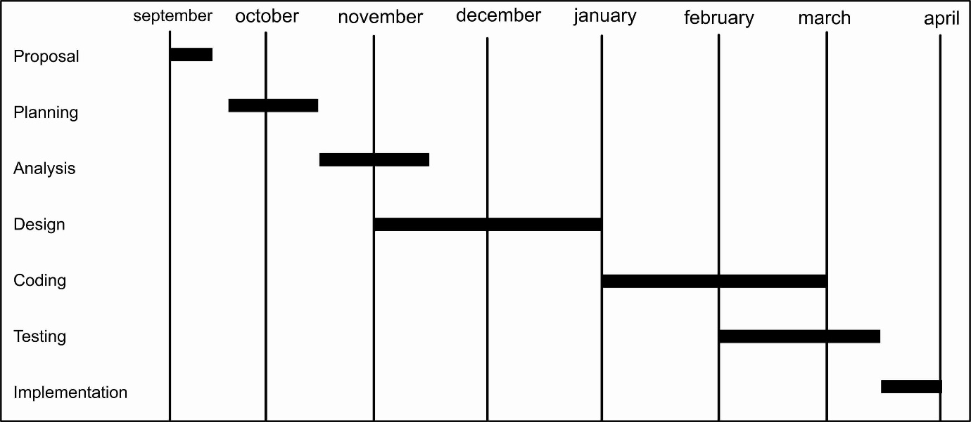

2 Chapter 2 Literature Review

2.1 Introduction
Online learning has become increasingly prominent as a valuable tool for supplementary education. It provides a wide range of benefits including accessibility, affordability, flexibility, and convenience, making it a powerful approach for acquiring knowledge. Active engagement of students in the learning process through collaborative online classes ensures continuity even in the face of disruptions. The literature review on e-learning underscores the importance of fair teaching practices and underscores the potential of online learning to democratize access to education among various populations. Despite its advantages, obstacles such as technological, financial, and managerial challenges impede the establishment of optimal practices for e-learning implementation. It is essential to recognize the limitations of current solutions to advance personalized e-learning pathways and enhance educational outcomes.
E-learning platforms have evolved significantly with the advancement of technology. Zhang (2010) and Piotrowski (2010) both emphasize the importance of computer networks and multimedia technology in these platforms, with Zhang specifically highlighting the role of direct interaction between teachers and learners. Wolfe (2015) further expands on this, noting the impact of social networking, online learning communities, and mobile devices on e-learning. Ying (2007) introduces the concept of a semantic grid-based architecture for e-learning platforms, which supports resource sharing and learning collaboration. These studies collectively underscore the dynamic and multifaceted nature of e-learning platforms.

2.2 Alternative Works
E-learning platforms are web-based systems that deliver educational content and facilitate learning through various online tools. These platforms are designed to provide flexible learning opportunities, allowing students to access materials at their own pace and convenience.
[1] Khan Academy is a non-profit educational platform offering free courses in a wide range of subjects, including mathematics, science, history, and computer programming. It features video tutorials of High-quality instructional videos explaining concepts step-by-step, practice exercises that are interactive exercises that allow students to apply what they've learned, personalized learning dashboard that tracks student progress and provides recommendations on what to learn next and teacher tools resources for teachers to track student progress and assign specific content. Khan Academy has the following benefits, accessibility meaning it has free access to educational content for all users, Self-paced Learning meaning students can learn at their own pace, revisiting materials as needed, and diverse content, wide range of subjects and levels covered. Khan Academy has the following limitations, limited Interaction meaning lack of direct interaction with instructors can be challenging for students who need personalized support and there is no formal accreditation which means courses do not offer formal credits or certifications.

[2] Coursera partners with universities and organizations to offer online courses, specializations, and degrees in various fields. It features video lectures. Courses include video lectures from university professors and industry experts. It provides quizzes and assignments Interactive quizzes and assignments to test knowledge and skills. Coursera also offers certificates, Option to earn course certificates and professional certifications. It has the following benefits High-Quality Content. Courses developed by prestigious universities and institutions. It has professional development which means courses designed for career advancement and skill development and it is flexibility, has ability to learn on-demand and access materials anytime. Coursera has the following limitations, cost which means many courses require payment to access full content and earn certificates. And it has limited varied quality of courses can vary depending on the provider.

[3] Udemy is an online learning platform aimed at professional adults and students, offering courses in various subjects taught by industry experts. Features video courses, thousands of video courses across a wide range of topics. It has lifetime access, once purchased, students have lifetime access to course materials. Udemy offers the ability to ask questions and interact with instructors. and peer reviews students can leave reviews and ratings for courses. Udemy has the following benefits like a wide range of topics. Extensive library of courses in both technical and non-technical fields. Udemy has affordable pricing, frequent discounts and promotions make courses accessible. It has instructor engagement through direct interaction with instructors through Q&A. Udemy has the following limitations variable quality, course quality can vary significantly between instructors and there is no formal accreditation which means courses do not typically offer formal accreditation or degrees.

Tutoring platforms provide personalized educational support through one-on-one or group tutoring sessions, often focusing on specific subjects or skills.
[4] Wynant is an online marketplace for tutoring services, connecting students with tutors for one-on-one sessions. Features tutor profiles contain detailed profiles with qualifications, experience, and student reviews. It has subject variety meaning tutors available for a wide range of subjects and levels.it has the following benefits, scheduling flexibility meaning students can schedule sessions at their convenience, In-Person and Online Options which means choice of in-person or online tutoring sessions. Udemy has personalized attention meaning it has one-on-one tutoring tailored to individual student needs. It has qualified tutors qualified and experienced tutors. Flexible scheduling, sessions can be scheduled around the student's availability. Udemy has some limitations also like one-on-one tutoring can be expensive and quality variability meaning quality of tutoring can vary based on the tutor’s effectiveness and teaching style.

[5] Chegg Tutors offers online tutoring services with a focus on homework help and test preparation. It has instant tutoring and an option for on-demand tutoring sessions. Chegg has tutor matching automated, matching with tutors based on subject needs. Interactive Tools Use of digital whiteboards, text chat, and file sharing during sessions. Subscription Plans with various subscription options based on session frequency. Chegg tutors has the following benefits, easy access to tutoring help anytime. Range of subjects tutors available for a wide variety of subjects. It has interactive learning Tools to enhance the online tutoring experience. Chegg has the following limitations, subscription Costs Ongoing subscription fees can add up. Limited long-term engagement: Instant tutoring might lack the consistency of a regular tutor-student relationship.

2.3 Conclusion
E-learning and tutoring platforms each offer distinct advantages for supporting students, particularly those who are underperforming. E-learning platforms provide accessible, flexible, and diverse educational content but often lack the personalized interaction that can be critical for struggling students. Tutoring platforms, on the other hand, offer personalized and direct educational support through one-on-one sessions, which can be more effective for students needing additional help. However, these services can be costly and vary in quality.
An optimal solution for supporting underperforming students may involve integrating the strengths of both e-learning and tutoring platforms. Such a system could provide comprehensive educational content and resources while also offering personalized support through qualified tutors, ensuring that students receive the help they need to succeed academically. Future development in this area should focus on creating hybrid models that leverage the benefits of both approaches to maximize educational outcomes for all students.

3 Chapter 3 Analysis

3.1 Information gathering tools.

3.1.1 Questionnaire
A questionnaire is a list of questions or items used to solicit information from respondents and they can be used to collect quantitative or qualitative information. Questionnaire methods can be in two forms which are self-administered, or researcher administered. Self-administered questionnaires can be delivered online or in paper and pen formats, in person or through mail. All questions are standardized so that all respondents receive the same questions with identical wording whilst researcher administered questionnaires are interviews that take place by phone, in-person, or online between researchers and respondents. The questionnaire may contain open or closed ended questions. Open ended questions allow respondents to give answers in their own words hence there are no restrictions on their choices whereby closed ended questions offer a fixed set of choices to select from. Each group had a separate set of questions. Used google forms to create customized surveys and questioners and collect responses in real-time. Asked teachers and students about their preferences, needs and expectations from the e-learning platform.

3.1.1.1Advantages
Cost saving: One of the most economical methods for collecting quantitative data is through questionnaires. A cost-effective technique to rapidly gather voluminous amounts of information from a vast number of people in a very short length of time is to use self-administered questionnaires, where you are not required to engage surveyors to do face-to-face interviews.
Practical: In addition to being affordable, questionnaires are an efficient way to obtain information. They may be controlled in a variety of ways and targeted to the groups of your choosing. Both the format and the questions asked are flexible (open-ended or multiple choice). They provide a means to compile a ton of information on any topic. They may be applied in several different contexts, such as consumer feedback.

Comparability: Data that has been quantified can be used to gauge change as well as to compare it with other studies. As a result, surveys conducted monthly or annually become increasingly valuable with time.
Respondent Anonymity: Digital surveys offer the greatest sense of privacy and anonymity. This style of questionnaire yields the most truthful responses and works well for all kinds of industries and subjects.

3.1.1.2 Disadvantages
Dishonest Answers: Even though there are numerous benefits to questionnaires, lying can be a problem. It is possible that respondents do not always give honest answers. Several factors, such as social desirability bias and an effort to maintain privacy, can lead to this. Assuring responders that their privacy is respected, and that personal identification is prevented will halt dishonesty in its tracks.
Unanswered Questions: There is a possibility that some questions will go unanswered or overlooked when employing questionnaires. There is always a chance that inquiries will not get addressed if they are not necessary. A straightforward solution to this problem is provided by online questionnaires: make answering the question necessary.
Lack of personalization: Without taking the time and effort to personalize it, any piece of marketing collateral runs the risk of coming across as impersonal. If you cannot personalize it, some potential replies might be put off and won't react. This can be especially challenging when the survey or questionnaire is completed willingly on a website, independent of payment or email.

3.1.2 Interviews
This is a qualitative research technique which involves conducting intensive individual interviews with a small number of respondents to explore their perspectives on a particular idea, program, or situation. Interviews can be structured, unstructured or semi-structured. Structured interviews consist of a series of predetermined questions that all interviewees answer in the same order, they are usually straight forward. During unstructured interviews, no questions are prepared prior to the interview and data collection is conducted in an informal manner. Semi-structured interviews contain the components of both structured and unstructured interviews. Conducted interviews with key stakeholders, including administrators, students, teachers, and researchers to delve deeper into their perspectives and gather qualitative data. Used both structured and semi-structured interview formats to explore topics such as data requirements, usability expectations, security concerns. Conducted remote interviews with participants from anywhere across the country using zoom.

3.1.2.1Advantages
- It offers interviewers flexibility.
- The interview receives more responses than sent questionnaires, and those who are illiterate can still participate and respond.
- The interviewer can assess the respondent's nonverbal conduct.
- In contrast to interviews conducted over emails, which can have a completely different setting, the interviewer can choose the location for an interview in a private and quiet spot.
- Like with a questionnaire, the interviewer has control over the question order and can assess the respondent's spontaneity.

3.1.2.2Disadvantages
- Interview studies can be very time-consuming to conduct.
- Bias might arise during an interview. For instance, the respondent's responses may vary depending on how he perceives the interviewer's race, class, age, or physical attributes.
- Less anonymity is provided by interview research, which is a major worry for many respondents.
Since respondents can be in any region of the world or nation, there is a lack of accessibility to respondents (unlike when a study is conducted using mailed questionnaires).

3.1.3 Observation
The system analyst watches the system in action currently. Either directly or indirectly is possible. Indirectly, the system analyst employs a collection of cameras to observe the workplace, as opposed to directly going to the workplace and seeing the activities firsthand. Document observations regarding data entry, retrieval, sharing and analysis practices to identify points, inefficiencies, and opportunities for improvement.

3.1.3.1Advantages
Directness: Data can be gathered as it happens. It is not necessary for the observer to question subjects about their actions and reports from others.
Natural Environment: Data collected in an observation study represent the observed phenomena as they occur in their natural contexts, unlike data generated using other data gathering procedures, which artificiality into the research environment.
Longitudinal Analysis: The observer can conduct his or her research over a much longer period than the survey or experiment since the observation can be done in a natural context.
Non-Verbal Behavior: For gathering information about non-verbal behavior, observation is unquestionably preferable to survey research, experimentation, or document study. Some research concentrates on those who are unable to verbally report information or meaningfully express themselves.

3.1.3.2Disadvantages
Lack of control: The presence of a stranger (the observer), as well as the human error associated with observation and data collection, which may remain beyond the observer's control, are likely to skew the observations.
Difficulties in Quantification: In contrast to the quantitative measures frequently used in surveys and experimental studies, measurement in observational studies typically takes the form of the observer's unquantified perceptions.
Smallness in sample size: The sample size is typically maintained to a minimum since observational studies are typically conducted in-depth with data that are frequently subjective and challenging to quantify.

3.2 Description of existing system
The current system in Zimbabwe involves more of physical classes for supplementary education or extra lessons. Students might go to teacher’s houses or school to conduct extra lessons. The teachers might use WhatsApp as media of communication and sharing files such as homework and notes.

3.3 Data Analysis

3.3.1 UML Context Diagram

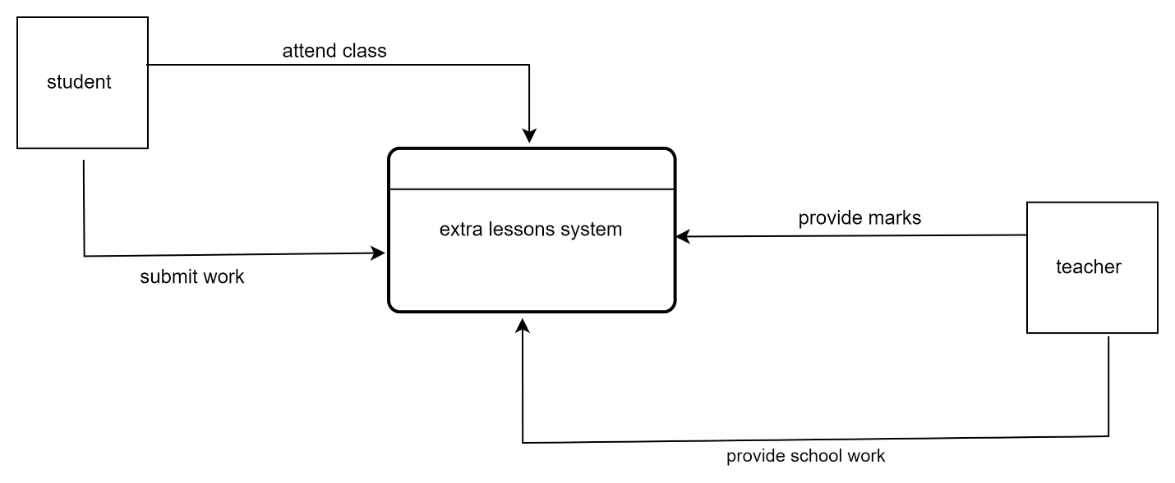

3.3.2 Data Flow Diagram

3.3.2.1 DFD Level 0
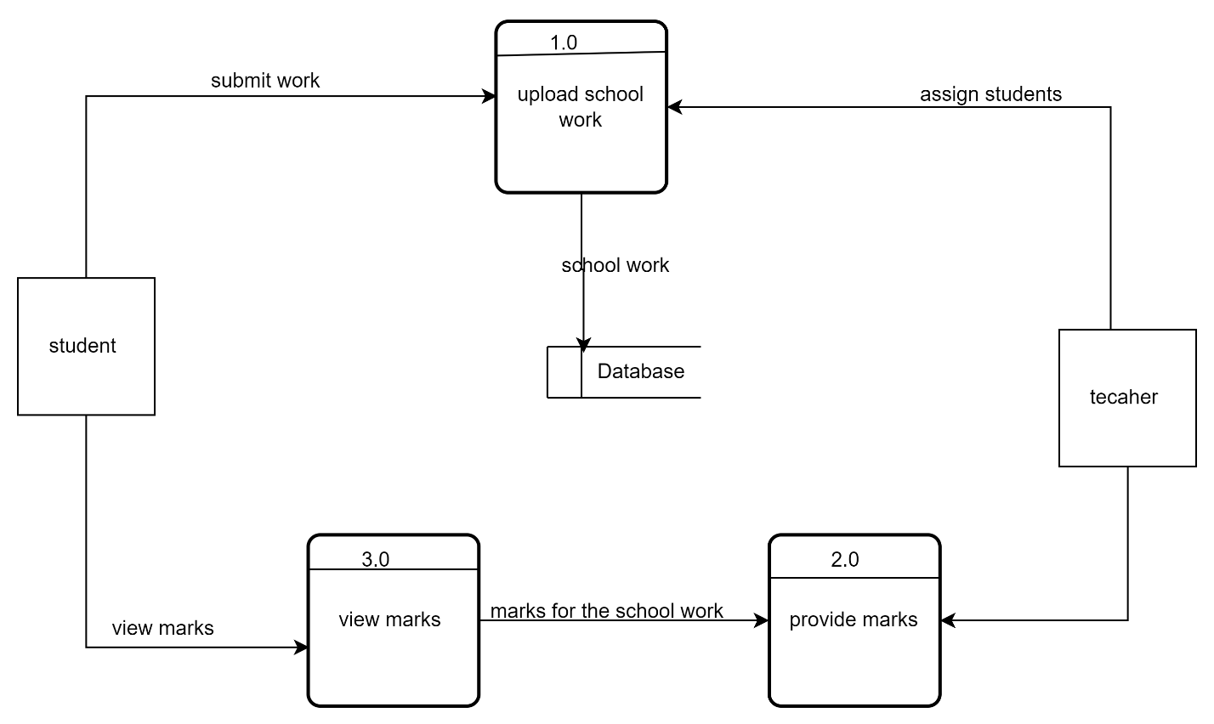

3.3.2.2 DFD Level 1
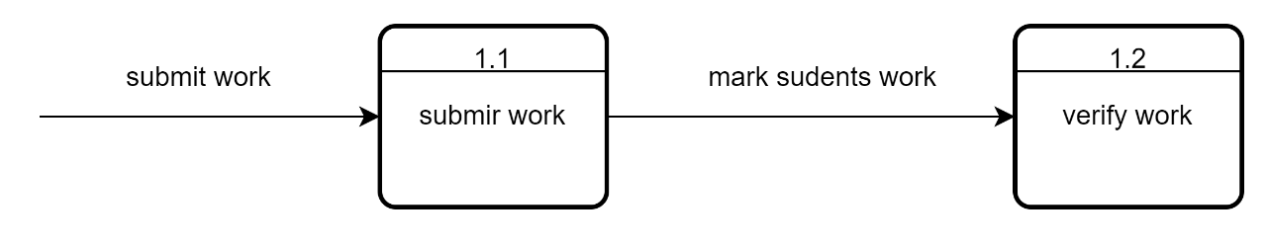

3.4 Evaluation of Alternative System

3.4.1 Functional and Non-Functional Requirements

3.4.1.1 Functional
Functional Requirements are the features and characteristics the system should have to support online education, for example the following functional requirements:
1. User Registration and Authentication - The system allows users (students and teachers) to register with a unique username, password, and email. The system verifies user email addresses during registration. The system allows users to log in using their credentials. The system provides password recovery options.
2.Teacher Document Verification - The system allows teachers to upload documents for verification. The system notifies the admin of new documents awaiting verification. The admin can verify or reject uploaded documents. The system notifies teachers of the verification status of their documents.
3. Subscription Management - The system allows teachers to subscribe to different subscription plans. The system manages payment processing for subscription plans. The system allows teachers to view and manage their subscription status. The system notifies teachers of upcoming subscription renewals or expirations.
4. Profile Management - The system allows users to update their profile information. The system shall display verified badges on teacher profiles once documents are verified.
5. Content Upload and Management - The system allows teachers and students to upload schoolwork and educational materials.
6. Video Conferencing - The system allows teachers to schedule video conferences with students. The system notifies students of scheduled video conferences. The system shall generate unique links for video conference sessions.
7. Search and Discovery - The system allows students to search for teachers based on subjects and other criteria.
8. Rating - The system allows students to rate their teachers after a session. The system allows students to leave feedback on teacher performance.
9. Admin Management - The admin can manage user accounts (suspend, delete). The admin shall have the ability to manage subscription plans and pricing.

3.4.1.2 Non-Functional Requirements
  - Performance - The system handles concurrent usage by multiple users without performance degradation.
  - Security - The system provides regular security updates and patches.
  - Usability - The system has an intuitive and user-friendly interface. The system provides clear navigation and accessible help resources.
  - Reliability - The system ensures high availability with an uptime of 99.9%.
  - Maintainability - The system is modular, allowing for easy updates and maintenance.
  - Compatibility - The system is compatible with major web browsers (Chrome, Firefox, Safari, Edge). It supports mobile access through responsive web design.

3.4.2 Use case Diagrams
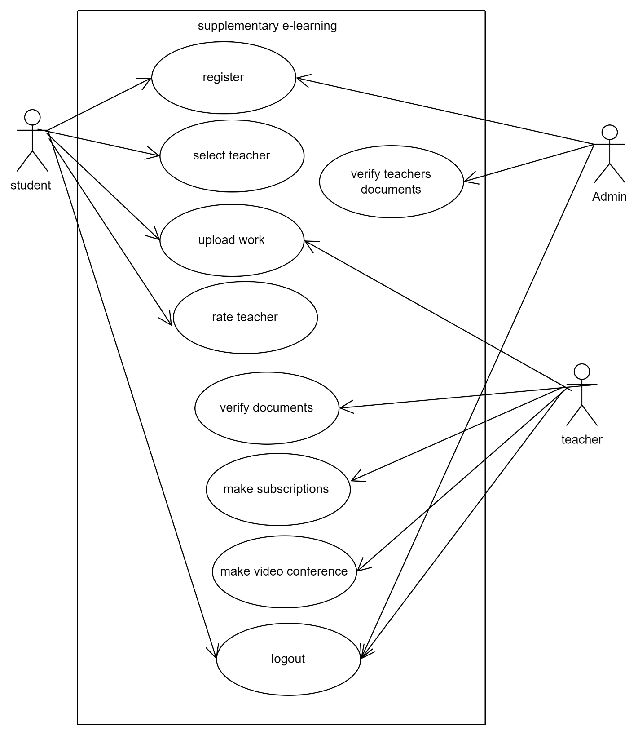

4 Chapter 4 Design

4.1 System Diagram

4.1.1Context Diagram

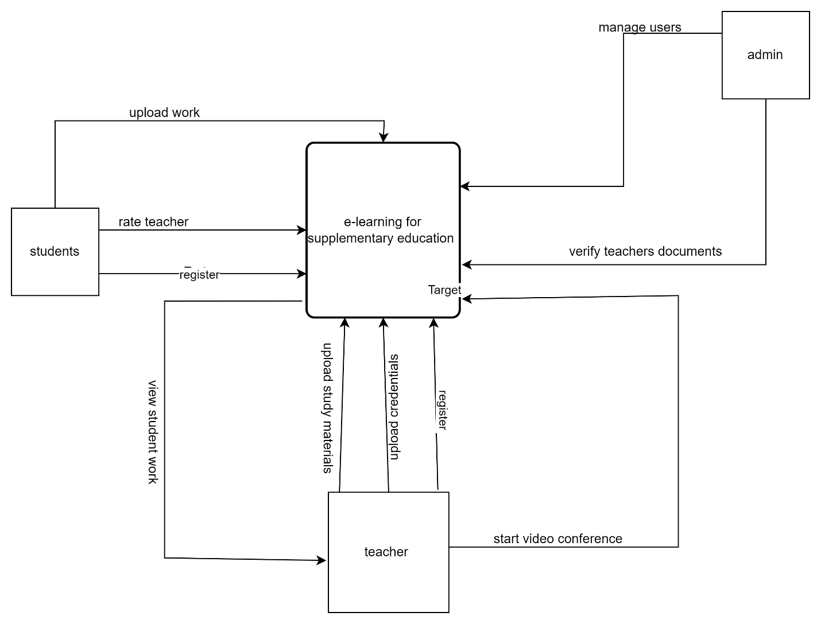

4.1.2 Dataflow Diagram

4.1.2.1 Level 0
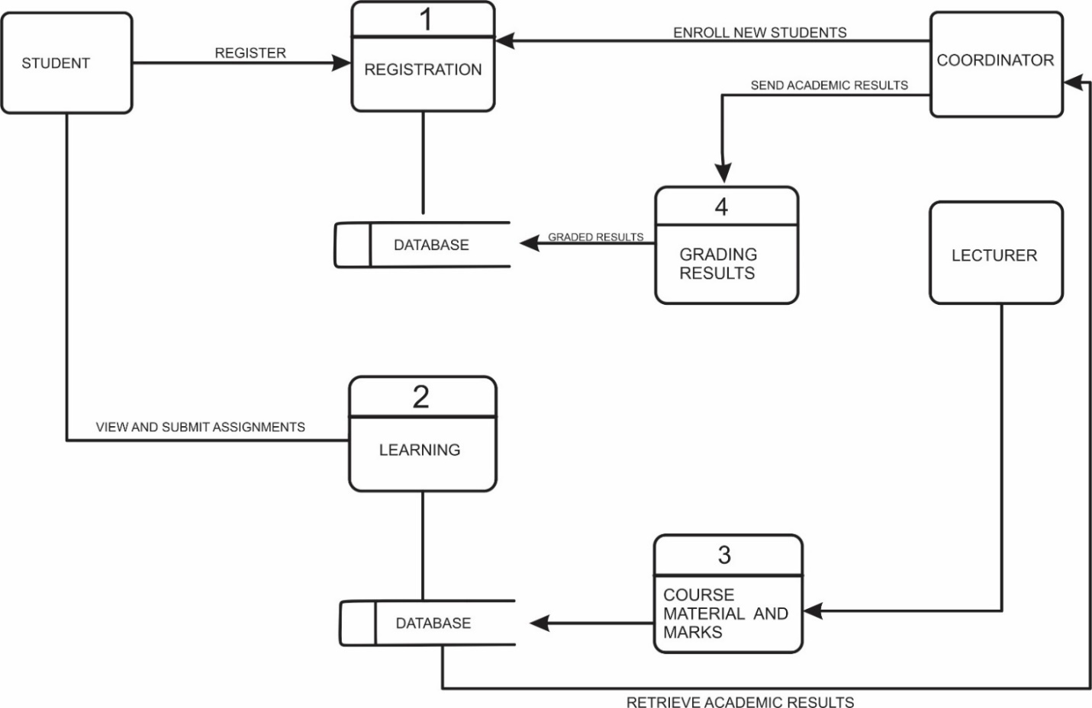

4.1.2.2 level 1 DFD

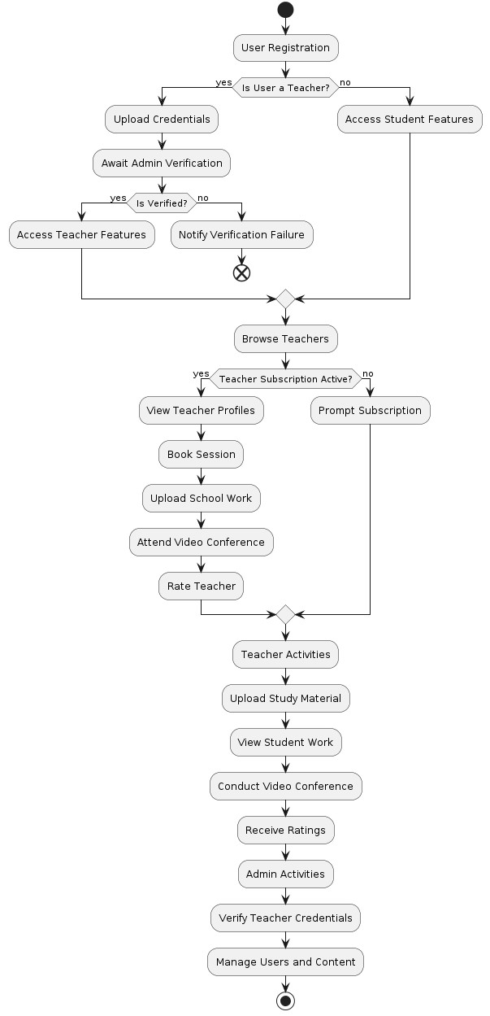
4.1.3 Activity Diagram

4.2 Architectural Design
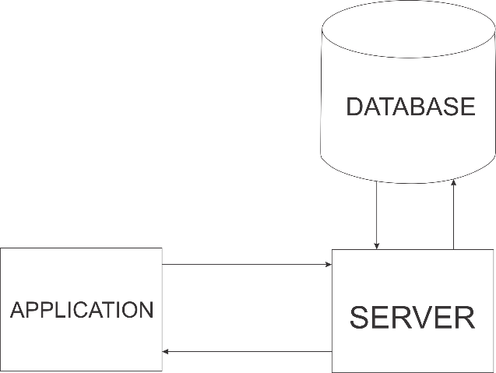

4.2.2 Networking
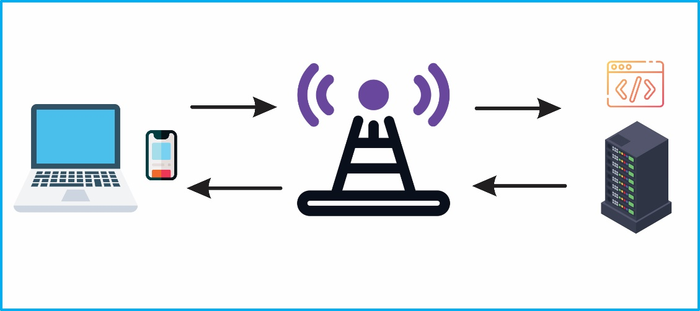

4.3 Database Design

4.3.1 Entity Relationship Diagram

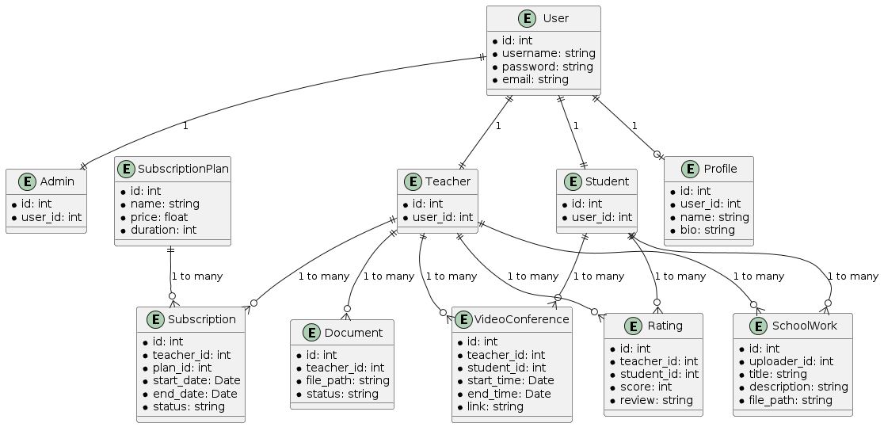

4.3.2 Normalized Database

4.3.2.1 First Normal Form (1NF)

4.3.2.1.1 User Table
UserID | Name | Email | Password | Usertype
1 | Thulani Thudza | thudza@gamil.com | 123 | Teacher
2 | Gucci Smith | gucci@gmail.com | 456 | Student

4.3.2.1.2 Documents Table 1NF
DocumentsID | UserID | DocumentsPaths | VerifiedStatus
101 | 1 | /docs/doc1.pdf | Verified
102 | 2 | /docs/doc2.pdf | Pending

4.3.2.1.3 Subscriptions (1NF)
subcriptionsID | UserID | SubscriptionsPlan | StartDate | EndDate
201 | 1 | Basic | 2024-01-01 | 2024-03-01

4.3.2.1.4 Content Table (1NF)
ContentID | UserID | ContentTitle | ContentPath | UploadDate
301 | 1 | Algebra | /content/c1.pdf | 2023-02-02 10:00

4.3.2.1.5 Videoconference Table (1NF)
ConferenceID | TeacherID | StudentID | ScheduleDate | ScheduleTime | ConferenceLink
401 | 1 | 2 | 2024-05-03 | 15:00 | /1cv/cv

4.3.2.1.6 Rating table (1NF)
RatingID | TeacherID | StudentID | Rating | Feedback | RatingDate
501 | 1 | 2 | 5 | Great session | 2024-05-02

4.3.2.2 Second Normal

4.3.2.2.1 User Table (2NF)
UserID | FirstName | LastName | Email | Password | Usertype
1 | Thulani | Thudza | thudza@gamil.com | 123 | Teacher
2 | Gucci | Smith | gucci@gmail.com | 456 | Student
Other tables do not change.

4.3.2.3 Third Normal
3NF requires that the tables in 2Nf and all the attributes are only dependent on the primary key (no transitive dependencies)

4.3.2.3.1 User Table
UserID | FirstName | LastName | Email | Password | Usertype
1 | Thulani | Thudza | thudza@gamil.com | 123 | Teacher
2 | Gucci | Smith | gucci@gmail.com | 456 | Student

4.4 Program Design

4.4.1 Class Diagram
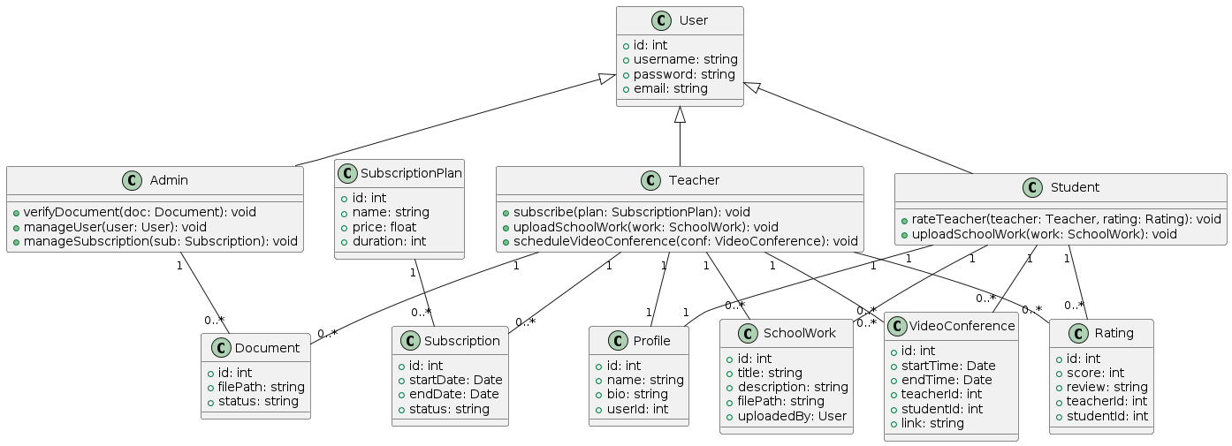

4.4.2 Sequence Diagram

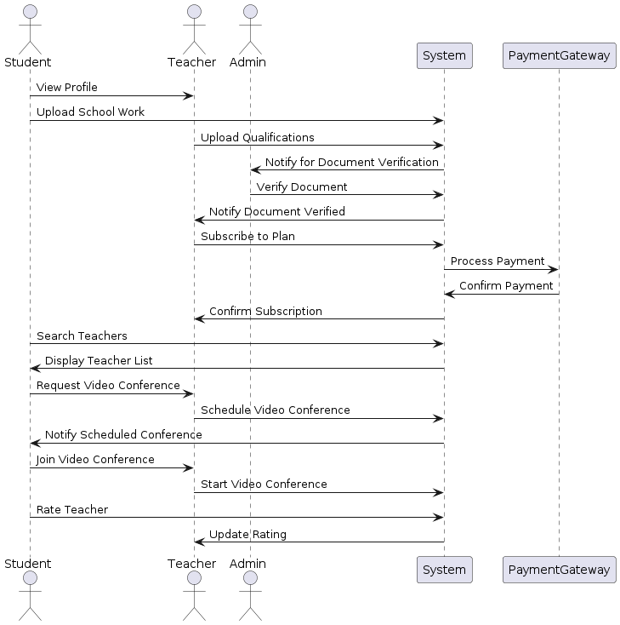

4.4.3 Package Diagram
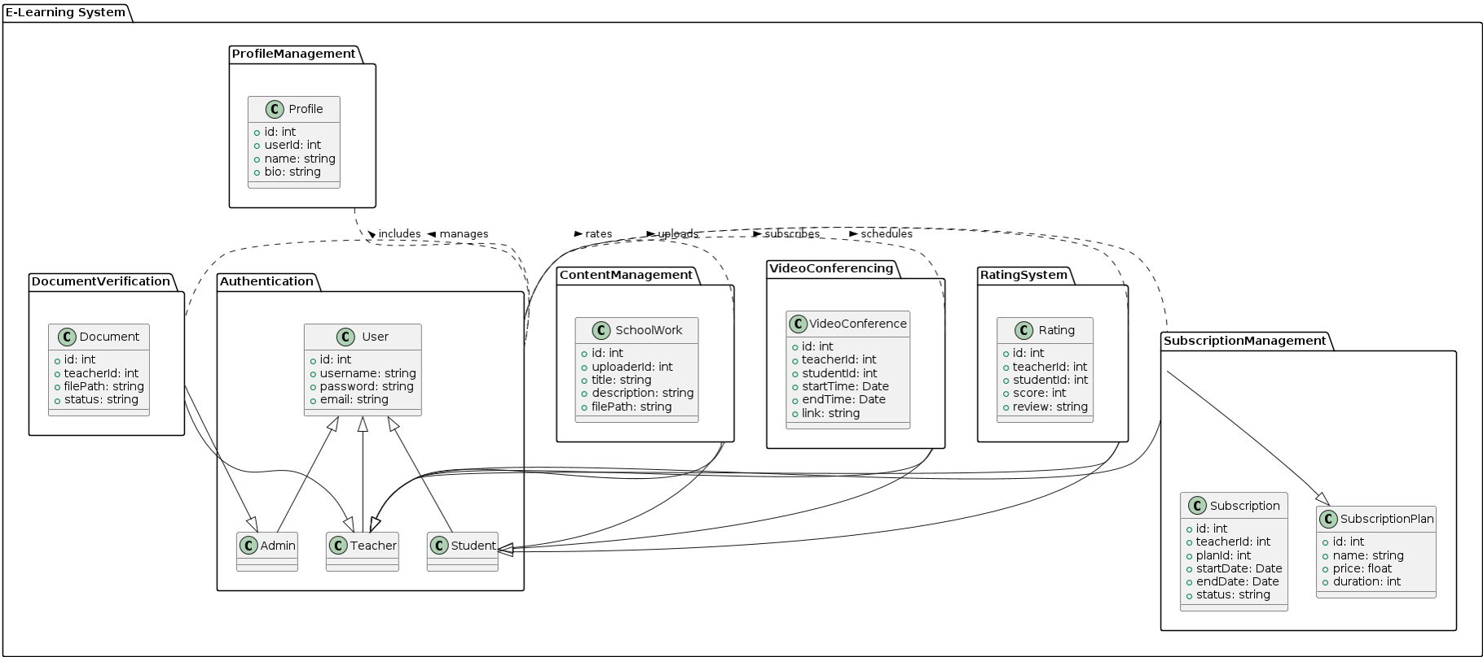

4.5 User Interface

4.5.1 Home Page
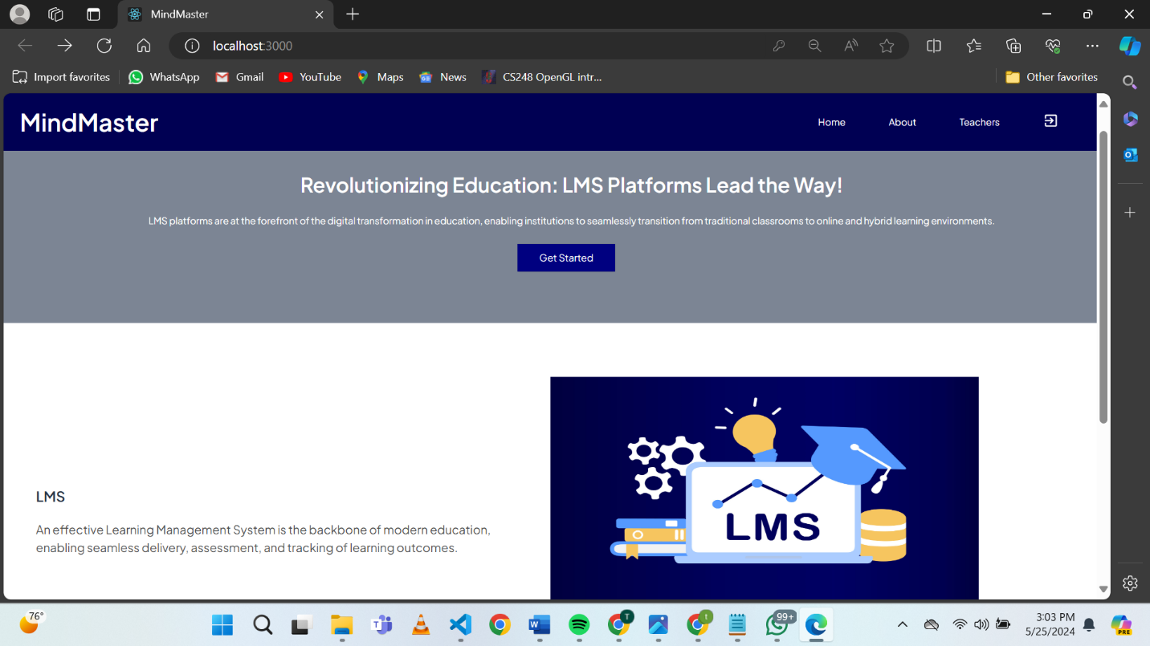
Fig 1: home page

4.5.2 Registration
Can select using toggle button to register as teacher or student
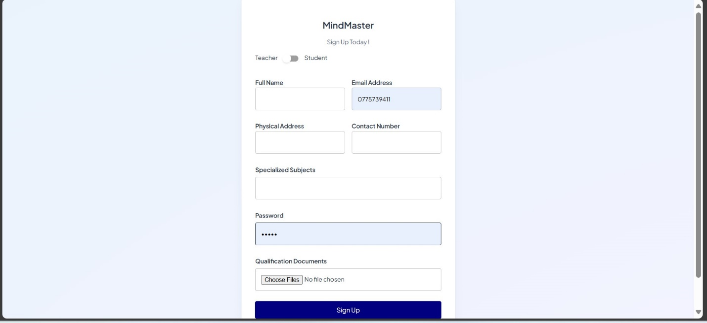
Fig 2: registration screenshot

4.5.3 Login
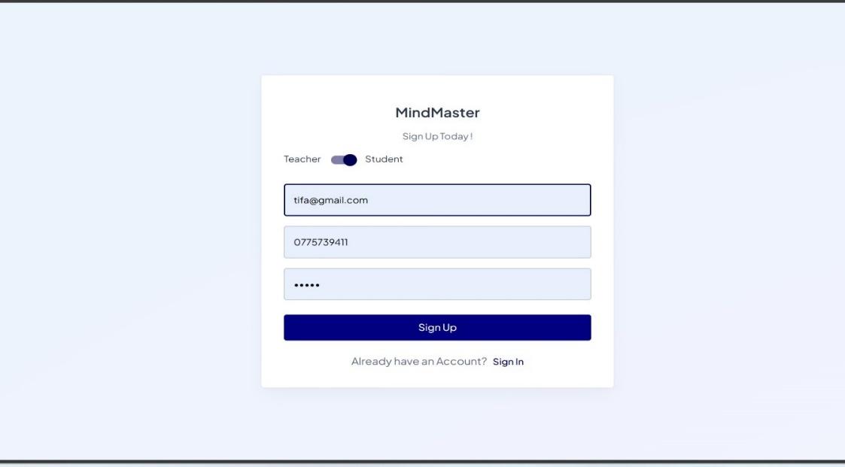
Fig 3: login screenshot

4.5.4 student dashboard
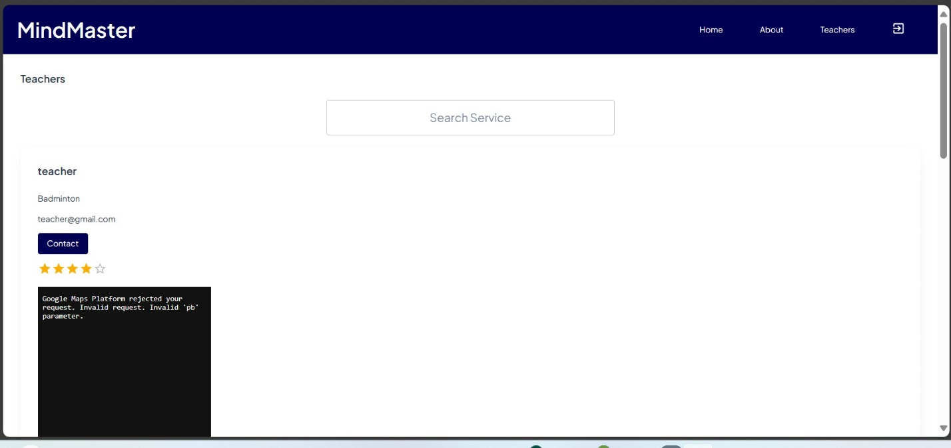
Fig 4: Student dashboard

4.5.5 Teacher’s dashboard
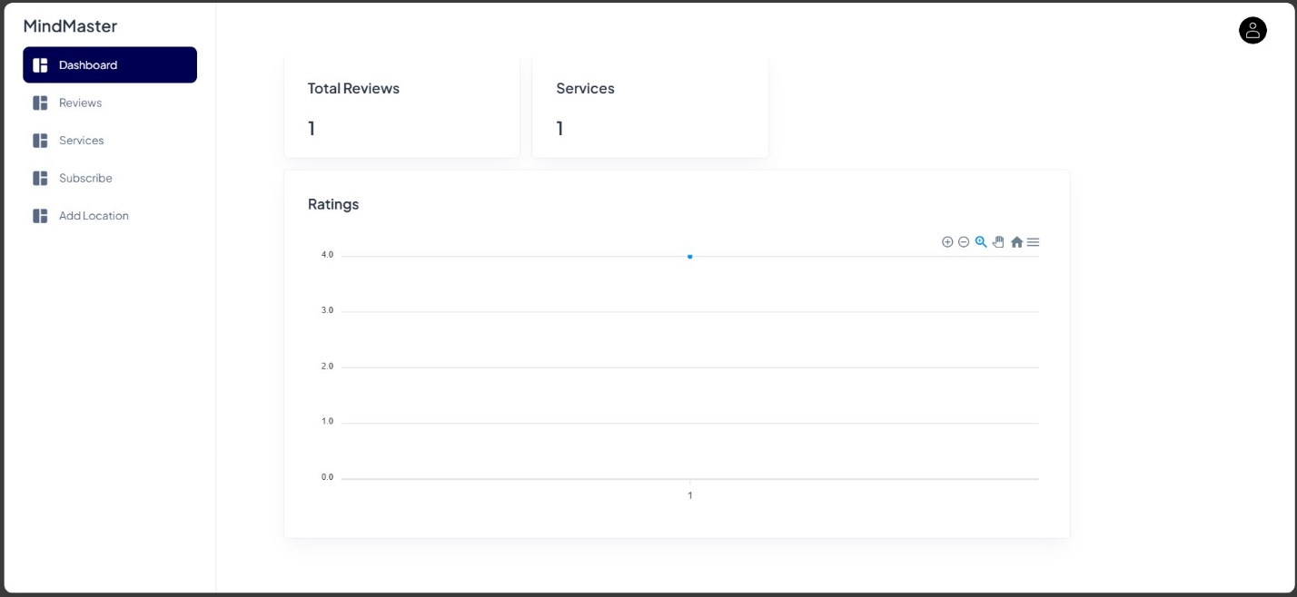
Fig 5: teacher’s dashboard screenshot

4.5.6 teacher starts video conference
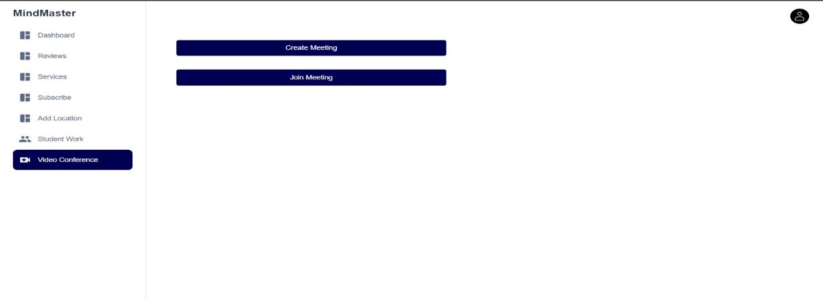
Fig 6: teacher starts video conferenc

4.5.7 Teacher viewing and marking students work
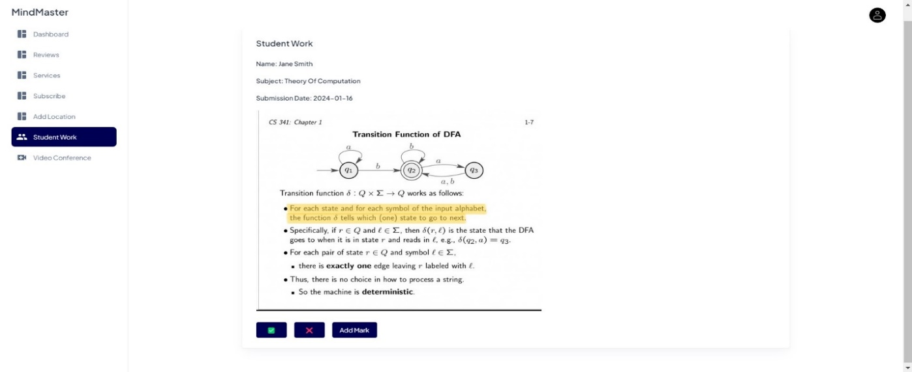
Fig 7: teacher viewing and marking screenshot

4.5.8 students viewing results
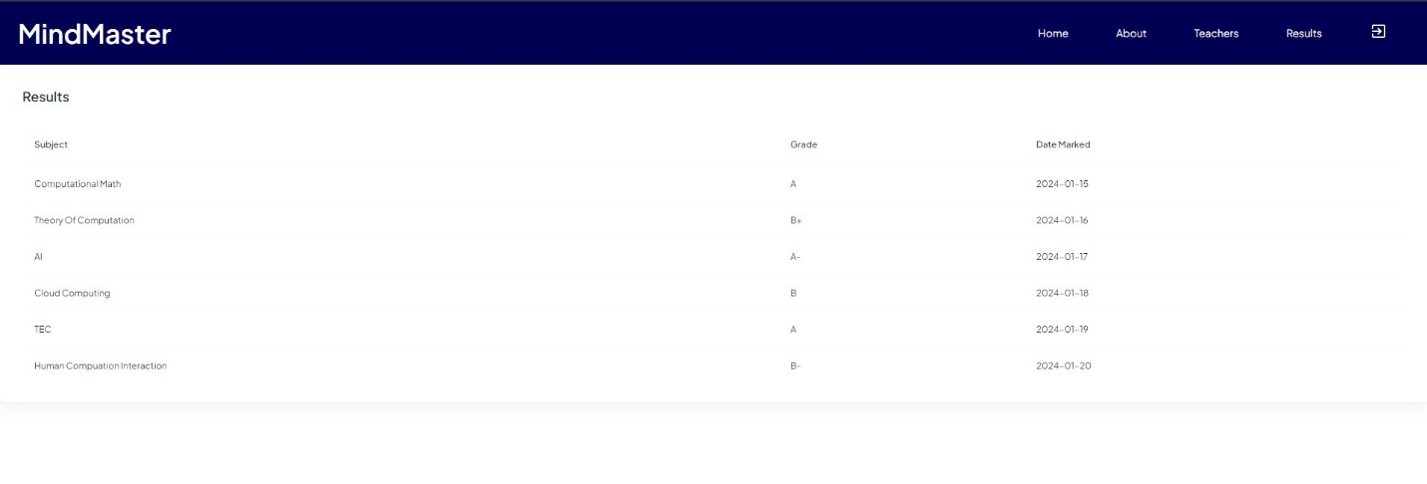
Fig 8 students viewing results screenshots

4.5.9 teachers making subscriptions
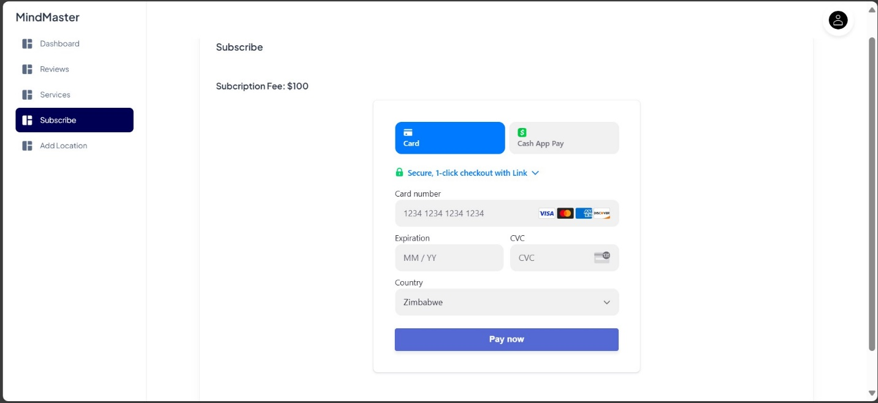
Fig 9: subscriptions screenshots

4.5.10 Videoconference
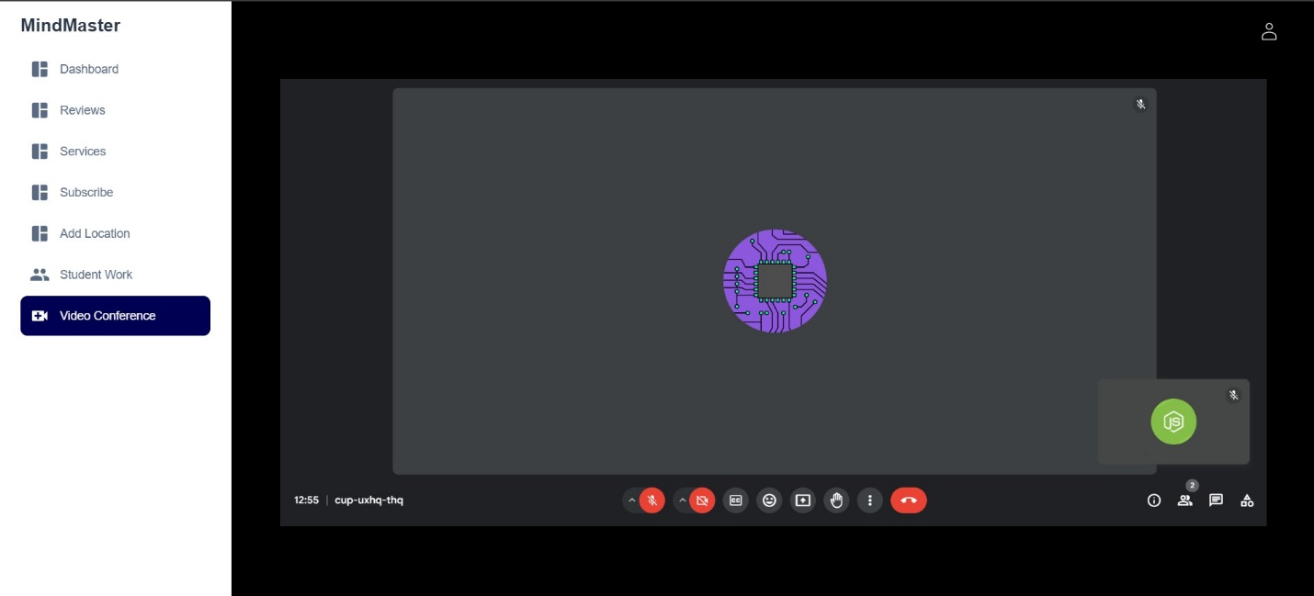
Fig 10: videoconference screenshots

4.5.11 Admin verifying documents.
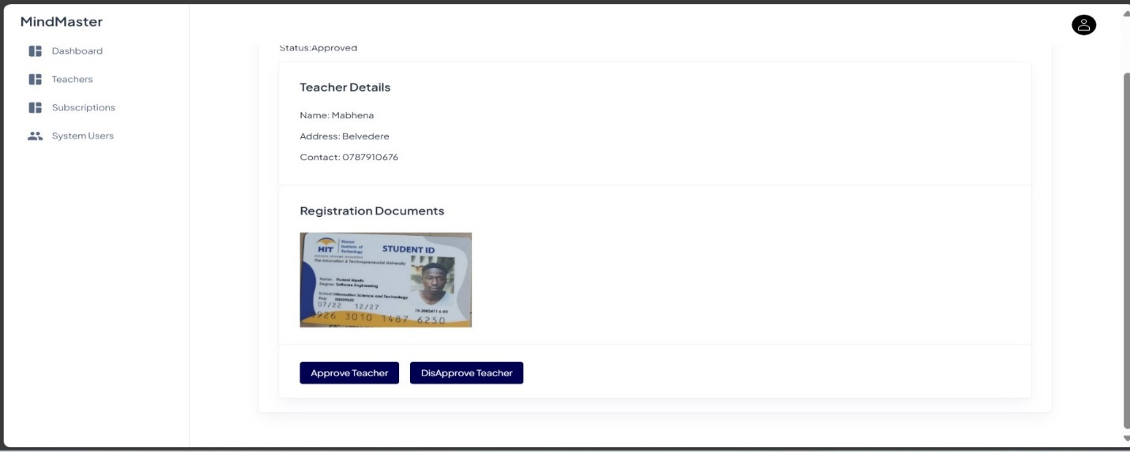
Fig 11: verifying documents screenshots

4.5.12 Students Rating the Teacher
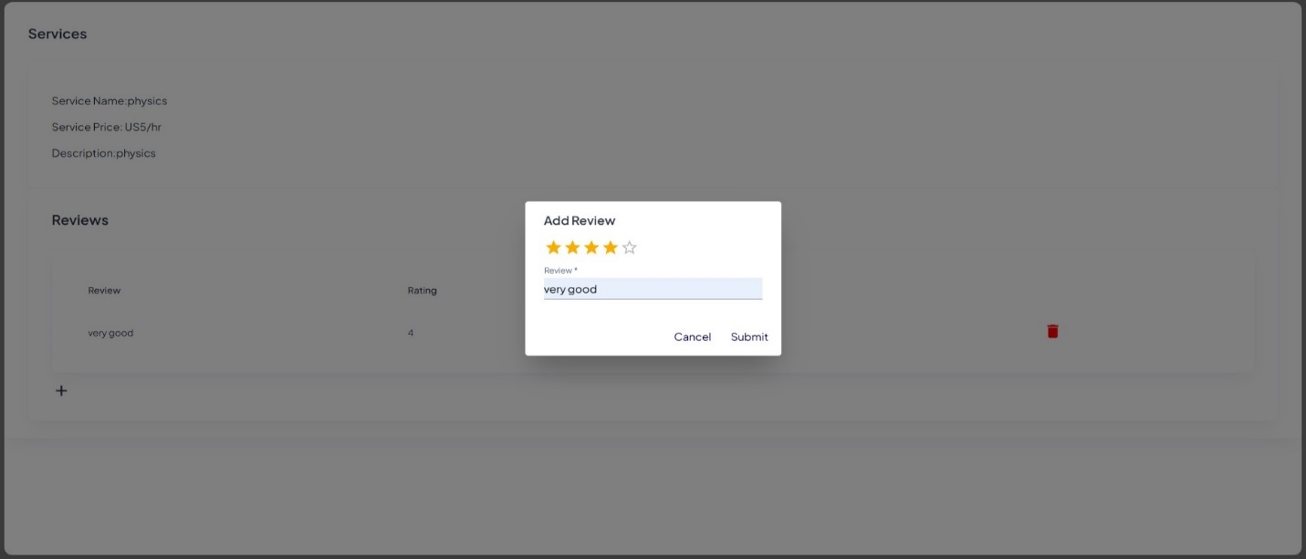
Fig 12: rating screenshots

5 Chapter Five Implementation and Testing

5.1 Pseudo Code

5.1.1 User registration and authentication
function registerUser(email, password, name, role):
if emailExists(email):
return "Email already registered"
hashedPassword = hashPassword(password)
userId = createUser(email, hashedPassword, name, role)
return "Registration successful, user ID: " + userId
function loginUser(email, password):
user = getUserByEmail(email)
if user is null:
return "User not found"
if checkPassword(password, user.hashedPassword):
return "Login successful, user ID: " + user.userId
return "Incorrect password"

5.1.2 Teacher Verification
function uploadCredentials(teacherId, documentPath):
createCredentialRecord(teacherId, documentPath, 'pending')
return "Credentials uploaded, awaiting verification"

function verifyCredentials(credentialId, status):
credential = getCredentialById(credentialId)
if credential is null:
return "Credential not found"
updateCredentialStatus(credentialId, status)
if status == 'approved':
updateTeacherVerification(credential.teacherId, true)
return "Credential verification " + status

5.1.3 Content Management
function uploadMaterial(teacherId, title, description, filePath):
materialId = createMaterial(teacherId, title, description, filePath, currentDateTime())
return "Material uploaded, material ID: " + materialId
function uploadWork(studentId, title, description, filePath):
workId = createWork(studentId, title, description, filePath, currentDateTime())
return "Work uploaded, work ID: " + workId
function getMaterials(teacherId):
return fetchMaterialsByTeacherId(teacherId)
function getWork(studentId):
return fetchWorkByStudentId(studentId)

5.1.4 Video conferencing
function startVideoConference(sessionId):
session = getSessionById(sessionId)
if session is null:
return "Session not found"
if session.status != 'pending':
return "Session cannot be started, current status: " + session.status
conferenceDetails = initiateVideoConference(sessionId)
updateSessionStatus(sessionId, 'in_progress')
return "Video conference started, details: " + conferenceDetails
function endVideoConference(sessionId):
session = getSessionById(sessionId)
if session is null:
return "Session not found"
updateSessionStatus(sessionId, 'completed')
terminateVideoConference(sessionId)
return "Video conference ended"

5.1.5 Rating System
function rateTeacher(sessionId, studentId, rating, review):
session = getSessionById(sessionId)
if session is null or session.studentId != studentId:
return "Invalid session"
if session.status != 'completed':
return "Session not completed"
ratingId = createRating(sessionId, studentId, session.teacherId, rating, review, currentDateTime())
return "Rating submitted, rating ID: " + ratingId

function getTeacherRatings(teacherId):
return fetchRatingsByTeacherId(teacherId)

5.1.6 Book Sessions
function searchTeachers(subject, rating):
return fetchTeachersBySubjectAndRating(subject, rating)

function bookSession(studentId, teacherId, scheduledTime):
if not isTeacherAvailable(teacherId, scheduledTime):
return "Teacher not available at the selected time"
sessionId = createSession(studentId, teacherId, scheduledTime, 'pending')
return "Session booked, session ID: " + sessionId

function updateSessionStatus(sessionId, status):
session = getSessionById(sessionId)
if session is null:
return "Session not found"
updateSessionStatus(sessionId, status)
return "Session status updated to " + status

5.1.7 Real Code

5.1.7.1. Teacher uploading file
const path = require("path");
let req_data = "";

let storage = multer.diskStorage({
destination: function (req, file, cb) {

// Uploads is the Upload_folder_name
cb(null, "uploads")
},
filename: function (req, file, cb) {
let ext = path.extname(file.originalname);
let {company_name} = req.body;
req_data = company_name + "-" + Date.now()+ext;
cb(null, company_name + "-" + Date.now()+ext)
}
})

// Define the maximum size for uploading
// picture i.e. 1 MB. it is optional
const maxSize = 5 * 1000 * 1000;

let upload = multer({
storage: storage,
limits: { fileSize: maxSize },
fileFilter: function (req, file, cb){

// Set the filetypes, it is optional
let filetypes = /xlsx|jpg|png|csv/;
let mimetype = filetypes.test(file.mimetype);

let extname =(path.extname(file.originalname).toLowerCase());

if (true) {
return cb(null, true);
}

cb("Error: File upload only supports the "
+ "following filetypes - " + filetypes);
}

// mypic is the name of file attribute
}).single("file");

function uploadFile(req,res){

return new Promise((resolve,reject)=>{

try {
upload(req.files,res,function(err){
if(err){
console.log(err);
resolve("failed");
}else{
let {name} = req.body;
resolve("success");
}
})

} catch (error) {
reject(error);

}

})

}

module.exports = {
uploadFile
}

5.2 Software Testing

5.2.1 Unit Testing
Test case | Function | Input | Expected Output | Pass/Fail
User Registration and | Capture and store user details correctly. | User details | User details stored successfully | pass
User Registration System | Handle errors and exceptions gracefully. | Invalid username or password input. | Error message is displayed. | pass
Teachers’ verification system | Authenticate teachers’ documents | Teachers’ qualifications | Qualifications uploaded, awaiting verification | pass
Teacher verification system | Verify credentials | Teachers’ qualifications | Qualifications verification approved or rejected | pass
Content Management | Upload work | Assignments, tests, schoolwork | Work uploaded | pass
Video Conference | Start video conference | sessionID, userID | Video conference started details (conference details) | pass
Video conference system | End video conference session | sessionID, or userID | Video conference ended | pass
Rating system | Students rate the teacher | Rate using stars from 1-5 and leave a comment | List of rating associated with teacher | pass
Searching teacher system | Select teacher of your choice based on ratings and feedback comments | Search using subjects you need help | List of teachers matching criteria | pass

5.2.2 Integration Testing
Component | Function | Input | Expected Output | Pass/Fail
User Registration and login | Capture and store all the user details | User details like emails, phone number | Users’ information stored and registration and login successful | pass
Teacher Registration and credential upload | Register teachers and able to collect their qualifications | Teacher details and qualifications | Registration successful, qualifications uploaded, awaiting verification | pass
Teacher upload material and student access | to see if the materials uploaded by the teacher reach the target audience, the student | School work, grading | Materials uploaded | pass
Student upload and teacher access | Students work reaches the teachers’ access | Assignments, tests, quizzes | Work uploaded | pass
Subscriptions and approval access to teacher | Payment for teachers that’s allows teacher to be visible to students | Card details | Payment successful or unsuccessful | pass
Start and end video conference | Video conferencing | sessionID, userID | Starts successful and ending video conference successful | pass

5.2.3 System Testing
System testing is a level of testing that validates the complete and fully integrated software product. The purpose of system testing is to evaluate the end-to-end system specifications. Usually, the software is only one element of a larger computer-based system. Ultimately, the software is interfaced with other software systems. Hence the whole system was tested, and the results are provided in the following sections.

5.2.4 Database testing
- Verify that the users’ details registered and stored in the database.
- Verify that the user’s details such as name, age, TeacherID, StudentID and emails and passwords are stored in the database.
- Verify that the teacher’s documents are fetched from the database when verifying qualifications.
- Verify the work uploaded by both the teacher and the student are fetched from the database.

5.2.5. Acceptance Testing
Test case | Function | Input | Expected Output | Pass/Fail
User Registration and | Capture and store user details correctly. | User details | User details stored successfully | pass
User Registration System | Handle errors and exceptions gracefully. | Invalid username or password input. | Error message is displayed. | pass
Teachers’ verification system | Authenticate teachers’ documents | Teachers’ qualifications | Qualifications uploaded, awaiting verification | pass
Teacher verification system | Verify credentials | Teachers’ qualifications | Qualifications verification approved or rejected | pass
Content Management | Upload work | Assignments, tests, schoolwork | Work uploaded | pass
Video Conference | Start video conference | sessionID, userID | Video conference started details (conference details) | pass
Video conference system | End video conference session | sessionID, or userID | Video conference ended | pass
Rating system | Students rate the teacher | Rate using stars from 1-5 and leave a comment | List of rating associated with teacher | pass
Searching teacher system | Select teacher of your choice based on ratings and feedback comments | Search using subjects you need help | List of teachers matching criteria | pass

5.3 Installation and Deployment
A zip folder containing all the setups and packages essential for this system to work will be provided.
N/B DO NOT CHANGE ANY CODE WHICH IS NOT MENTIONED IN THE INSTRUCTIONS AND INSTALL THE TOOLS AND PACKAGES IN THE ZIP FOLDER
- Extract the zip folder and install node, MySQL-connector, and visual studio code.
- Create a folder that contains a client folder and server folder.
- Run MySQL modules.
- Open admin on the MySQL module and create a database called eLearning.
- Import a database file in the extracted folder to the one you have created.
- Login to any of the 3 user accounts

5.4 Maintenance
- Once every month, check to see if the mobile application has not consumed 80% of its hosted environment storage space.
- Ensure that users are trained on safe keep of passwords.

6 Chapter 6 Conclusion and Recommendations

6.1 Results

6.1.1 Successful Registration
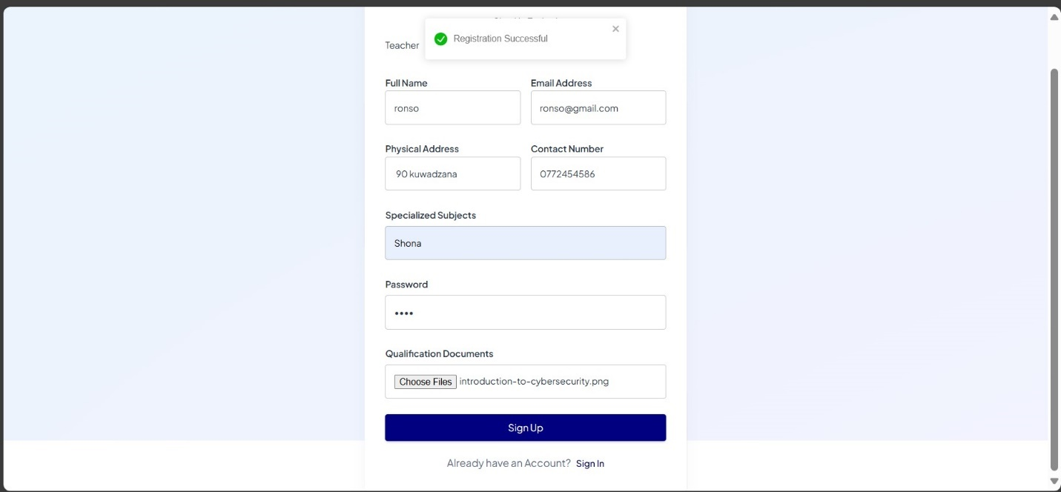
Fig 13. Successful registration screenshot

6.1.2 Successful Subscription
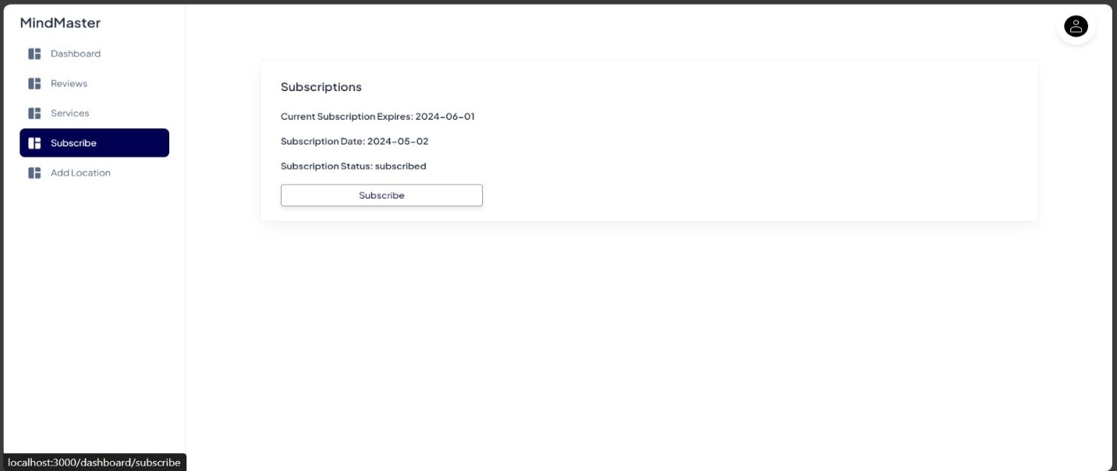
Fig 14: successful subscription screenshot

6.1.3 Successful teacher verification
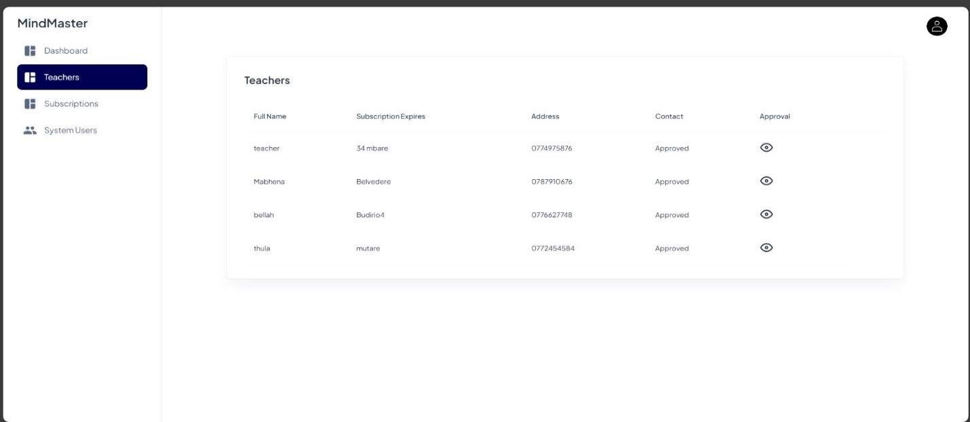
Fig 15: successful teacher verification screenshot

6.1.4 Successful student work upload
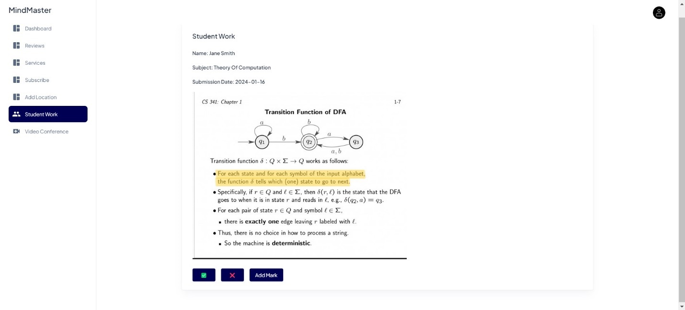
Fig 16: successful student work upload screenshot

6.1.5 Successful Teacher rating
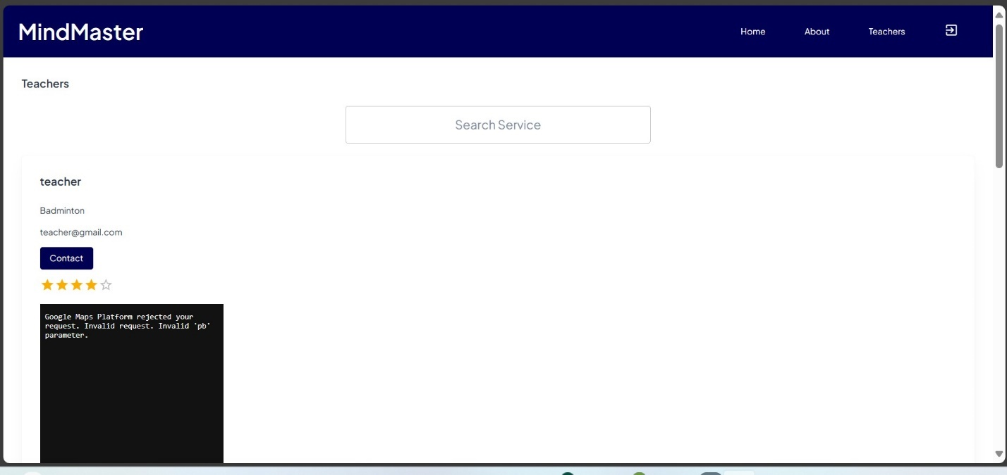
Fig 17: successful teacher rating screenshot

6.1.6 Successful Video conference
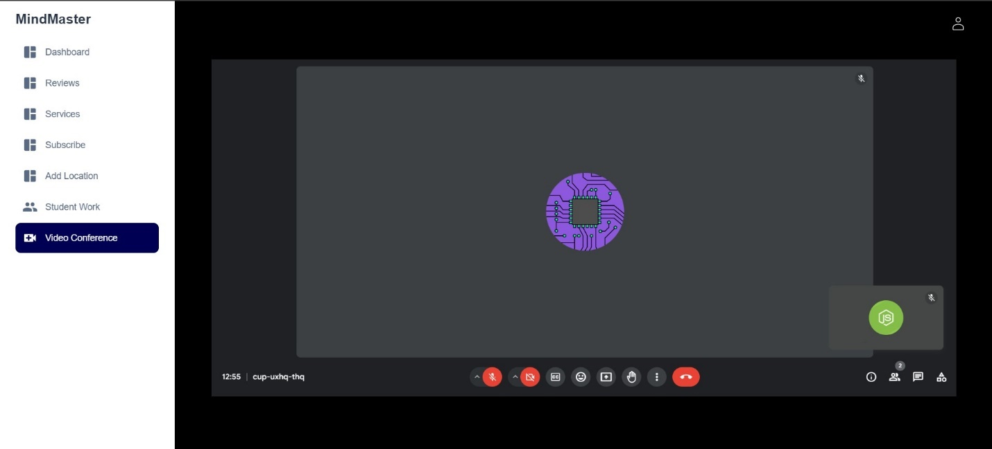
Fig 18: successful video conference screenshot

6.1.7 validation
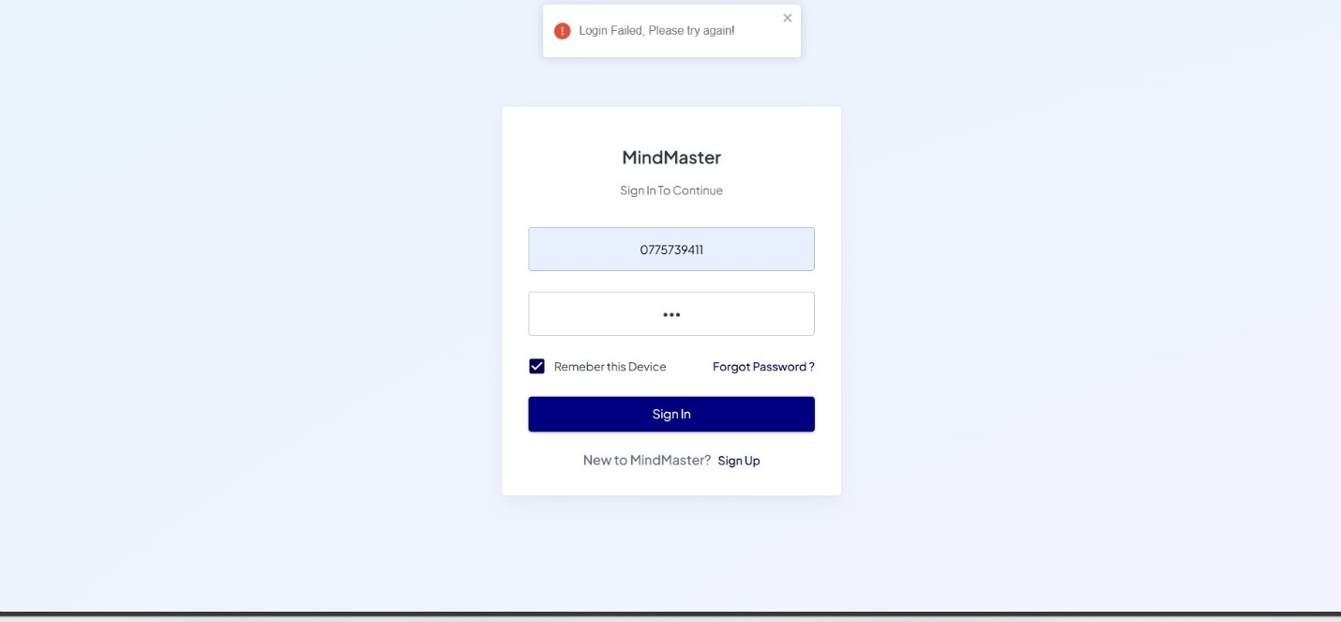
Fig 19: validation screenshot

6.1.8 Teacher Successfully add services.
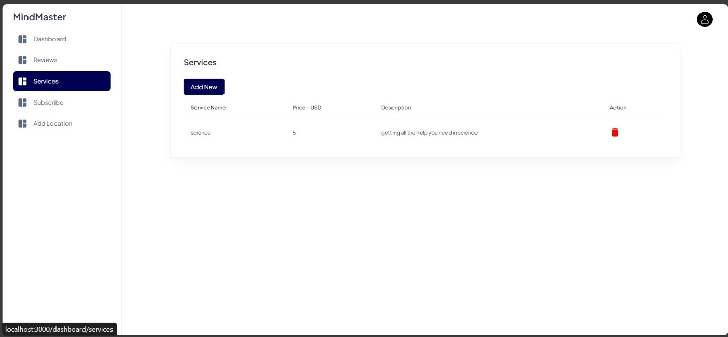
Fig 20: adding services screenshots

6.1.9 Document Verification
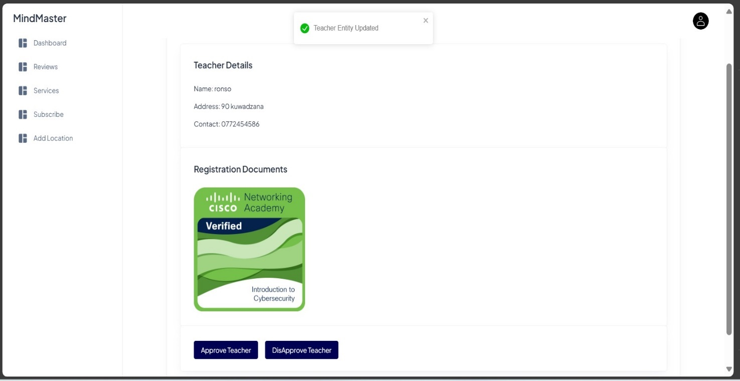
Fig 21: document verification screenshot

6.2 Summary

Project Name: E-learning for supplementary education

Project Objective: The E-Learning System is designed to support students in Zimbabwe who seek additional help in subjects where they are underperforming. This web-based platform connects students with verified teachers who can provide tutoring and educational support through various functionalities. The system ensures a secure, efficient, and user-friendly environment for both students and teachers.

Background Information: The current system for students doing extra lessons is outdated provided with the technology the world has write now students should optimize the technology by using an e-learning system.
Requirements: The e-learning platform should be easy to use, available to all devices and major web browsers.

Problems: The main challenge is developing a system that is both secure and user-friendly. Another challenge is ensuring that the system can handle many students and to keep the teachers documents safe or confidential.

Analysis: To address these challenges, we will conduct research on the latest e-learning systems and assuring police for data disclosure for the qualifications details of the teacher.

Conclusion: The E-Learning System for Zimbabwe is a comprehensive platform designed to enhance educational support for students and provide a structured, efficient, and interactive learning environment. By connecting students with verified teachers, the system aims to improve academic performance and provide valuable educational resources. The successful implementation of this system will contribute significantly to the educational landscape in Zimbabwe.

6.3 Recommendations

- Guaranteeing that the platform is easy to understand and available to all students and teachers in the country.
- Performing routine security audits to find and fix potential security holes
- Planning of action in case of technical difficulties or other issues during the voting process.
- Ensures the content is culturally relevant and aligned with the Zimbabwean curriculum and educational standards.
- Continuously updating and adding new features to the platform based on emerging educational trends and technologies.
- The system architecture to be easily scalable to accommodate future growth in user base and content volume.
- Implement robust data protection measures to ensure the privacy and security of user information, including encryption and secure data storage.

6.4 Future Works
- Mobile Application Development - Develop native mobile applications for iOS and Android to provide a seamless learning experience on smartphones and tablets and implement offline capabilities so that students can download materials and access them without an internet connection.
- Virtual and Augmented Reality - Integrate virtual reality (VR) and augmented reality (AR) technologies to create immersive learning experiences, particularly for subjects like science and history.
- Virtual Classrooms - Develop virtual classroom environments where students and teachers can interact in a simulated space, enhancing remote learning.
- Expanded Course Offerings - Certification Programs, Partner with educational institutions to offer certification programs that provide formal recognition of students' achievements.
- Multi-Language Support: Expand language support to include more local languages and dialects, making the platform accessible to a broader audience.
- Accessibility Features - Implement features to support students with disabilities, such as screen readers, text-to-speech, and adjustable text sizes and colors.

BIBLOGRAPHY

APPENDIX 1: DATA COLLECTION TOOLS
Questionnaires were distributed to gather insights into the current system before designing the upcoming system. A sample group of forty individuals, including the students and teachers, received the questionnaires. The selection process employed a random sampling method.
To public:
Q1. Do you possess a laptop or a smartphone? YES/NO
Q2. Have you used any e-learning platform before? YES/NO
Q3. Do you consider user comments to be important? YES/NO
_______________________________________________________________________
Q4. Are you influenced by fake reviews? YES/NO

For Student:
Q1. Have you ever done online learning? YES/NO
Q2. Do you like learning from the comfort of your house? YES/NO
Q3. How do you see e-learning in the next years?___________________________________________________________________________ ___________________________________________________________________________ ______
Q4. Do you believe technology can be beneficial? YES/NO
Q5. Are you interested in obtaining student data? YES/NO
Q6. Does your organization utilize computers? YES/NO

APPENDIX 11 User Manual of the working system
Getting Started:
System Requirements
-Operating System: Windows, macOS, Ubuntu 20.04, or later.
- Browser: Latest version of Chrome, Firefox, Safari, or Edge.
- Internet Connection: Stable internet connection with at least 2 Mbps speed.
- Hardware: Webcam and microphone for video conferencing.
Accessing the Platform:
1. Open your web browser.
2. Navigate to the platform's URL: `https://www.elearning-zim.com`.
3. You will be directed to the homepage where you can register or log in.
Student Registration:
1. On the homepage, click on the "Register" button.
2. Select "Student" as your role.
3. Fill in your details: Full Name, Email, Password, School, Grade.
4. Click "Submit" to complete the registration.
5. You will receive a confirmation email. Click the link in the email to verify your account.
Teacher Registration:
1. On the homepage, click on the "Register" button.
2. Select "Teacher" using a toggle button
3. Fill in your details: Full Name, Email, Password, Subject Specialization, Qualifications.
4. Click "Submit" to complete the registration.

4. User Login:
Logging In
1. On the homepage, click on the "Login" button.
2. Enter your registered email and password.
3. Click "Submit" to log in to your dashboard.
Password Recovery:
1. On the login page, click "Forgot Password?"
2. Enter your registered email.
3. You will receive an email with instructions to reset your password.
4. Follow the instructions to reset and create a new password.
Admin Verification Process:
1. Admins will review the submitted credentials.
2. If the documents are valid, the teacher's status will be updated to "Verified."
3. Teachers will receive a notification about the verification status.

APPENDIX 111 Sample Code
User Registration and login

//Register Users
router.post("/register",(req,res)=>{
const reg_data = req.body;
console.log("Data",reg_data);
console.log("Paass",reg_data.password);

const sql = "INSERT INTO users (full_name,address,email,contact_number,password) VALUES (?,?,?,?,?)";
const check_sql = "SELECT * FROM users WHERE full_name = ? OR email = ?";
let password = bcrypt.hashSync(reg_data.password,10);
const data = [reg_data.full_name, reg_data.address,reg_data.email, reg_data.contact_number, password];

try {

pool.query(check_sql,[reg_data.full_name, reg_data.email],(err,results)=>{
if(err){
console.log(err);
return res.status(500).send(err);
}else{
if(results.length>0){
console.log("duplicate")
return res.status(200).send("already registered");
}else{
pool.query(sql,data,(err)=>{
if(err){
return res.status(500).send(err);

}else{
return res.status(200).json({message:"User registered"});
}
})

}
}
})

} catch (error) {
console.log(error);
return res.status(500).send(error);

}
});

//Login Users
router.post("/login",(req,res)=>{
const login_data = req.body;
console.log(login_data);
const sql = "SELECT * FROM company WHERE email = ? OR contact = ?";

try {
pool.query(sql,[login_data.email,login_data.email],(err,results)=>{
if(err){
console.log(err);
return res.status(500).send(err);
}else{
console.log(results)
if(results.length>1){
return res.status(500).send("Cannot login, please contact the administrator!");
}else if(results.length == 1){
let verify = bcrypt.compareSync(login_data.password, results[0].password);

if(verify){
return res.status(200).json({message:"Login Successful",user:results[0]});
}else{
return res.status(200).send("Login Failed");
}
}

else{
return res.status(200).send("Login Failed");
}
}
})
} catch (error) {

}
});

Adding or deleting services for teachers.

//Add Service
router.post("/add/service",(req,res)=>{
const serviceData = req.body;
const sql = "INSERT INTO services (company_id, service_name, service_price,description) VALUES (?,?,?,?)";
const data = [serviceData.company_id, serviceData.service_name, serviceData.service_price, serviceData.serviceDescription];
try {
pool.query(sql,data,(err,results)=>{
if(err){
console.log(err);
return res.status(500).json({error:err});
}else{
if(results.affectedRows === 1){
return res.status(200).json({message:"success"});
}
}
})
} catch (error) {
return res.status(500).json({error});
}
});

//Get All Services
router.post("/services",(req,res)=>{
const {company_id} = req.body;
console.log(req.body);
const sql = "SELECT * FROM services WHERE company_id = ?";
const data = [company_id];
try {
pool.query(sql,data,(err,results)=>{
if(err){
console.log(err);
return res.status(500).json({err});
}else{
if(results.length > 0){
return res.status(200).json({message:"success",services:results});
}else{
return res.status(404).json({message:"no services"});
}
}
})
} catch (error) {
return res.status(500).json({error});
}
});

//Delete Service
router.post("/service",(req,res)=>{
const serviceData = req.body;
const sql = "DELETE FROM services WHERE service_id = ?";
const data = [serviceData.service_id];
try {
pool.query(sql,data,(err,results)=>{
if(err){
console.log(err);
return res.status(500).json({err});
}else{
// console.log(results);

if(results.affectedRows === 1){
return res.status(200).json({message:"service deleted"})
}else{
return res.status(200).json({message:"no record to delete"});
}
}
})
} catch (error) {
return res.status(500).json({error});
}

})

Refences
1. Research and Markets. (2021). E-Learning Market - Growth, Trends, COVID-19 Impact, and Forecasts (2021 - 2026).
2. Gura, M., & Legeard, B. (2004). An Approach to the Certification of E-Learning Services Based on Model-Based Testing. In International Conference on Web Engineering (pp. 106-114). Springer, Berlin, Heidelberg.
3. Darling-Hammond, L., & Baratz-Snowden, J. (2005). A Good Teacher in Every Classroom: Preparing the Highly Qualified Teachers Our Children Deserve. San Francisco, CA: Jossey-Bass.
4. Reeves, T. C., & Hedberg, J. G. (2003). Interactive Learning Systems Evaluation. Educational Technology Publications.
5. UX Planet. (2024). Designing Rating and Review Systems. Available at: [UX Planet] (https://uxplanet.org/)
6. World Bank. (2021). How Countries are Using EdTech to Support Remote Learning During the COVID-19 Pandemic. Available at: [World Bank Report] (https://www.worldbank.org/en/topic/edutech/brief/how-countries-are-using-edtech-to-support-remote-learning-during-the-covid-19-pandemic)
7. Zimbabwe Ministry of Primary and Secondary Education: Official guidelines and standards for the national curriculum. [Ministry of Primary and Secondary Education] (http://www.mopse.gov.zw/)
8. Anderson, T., & Elloumi, F. (2004). Theory and Practice of Online Learning. Athabasca University. 9.Bates, A. W. (2015). Teaching in a Digital Age: Guidelines for Designing Teaching and Learning. BCcampus OpenEd.
10. Zoom API Documentation. (2024). Available at [Zoom](https://marketplace.zoom.us/docs/guides)

